|  |  |  |
| --- | --- | --- |
| Nama | : Ludang Prasetyo Nugroho | [Teknik Komputer ( S1)](https://www.utdi.ac.id/) |
| Nim Matkul | 225510017  : Prak system IOT |  |
|  |  | **PRAKTEK** |

Praktek

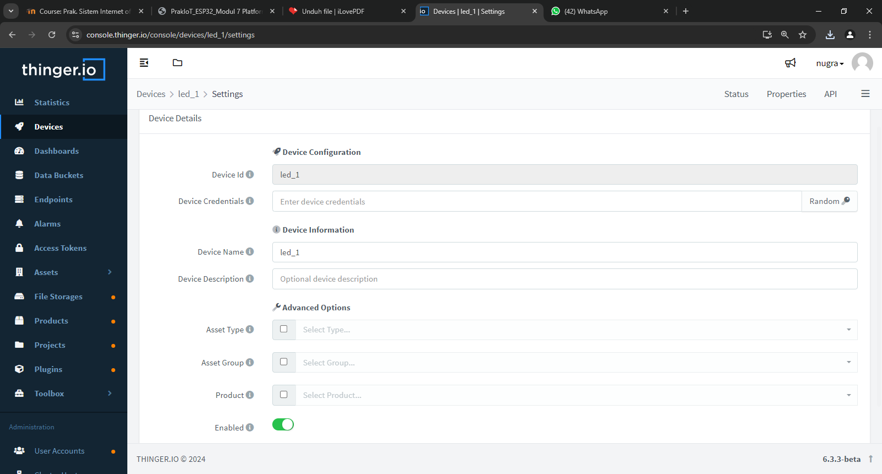Code program

- Code Esp

|  |
| --- |
| #define THINGER_SERIAL_DEBUG |
| #include <ThingerESP32.h> |
| #include "arduino_secrets.h" |
| #define LED1 12 |
| #define LED2 13 |
| #define Sensor 32 |
| ThingerESP32 thing(USERNAME, DEVICE_ID, |
| DEVICE_CREDENTIAL); |
| void setup() { |
| // untuk debugging |
| Serial.begin(115200); |
| // set LED1 sebagai output |
| pinMode(LED1, OUTPUT); |
| // SSID dan password Access Point |
| thing.add_wifi(SSID, SSID_PASSWORD); |

|  |
| --- |
| // resourse input on/off led1 LED1 |
| thing["led1"] << digitalPin(LED1); |
| } |
| void loop() { |
| thing.handle(); |
| } |

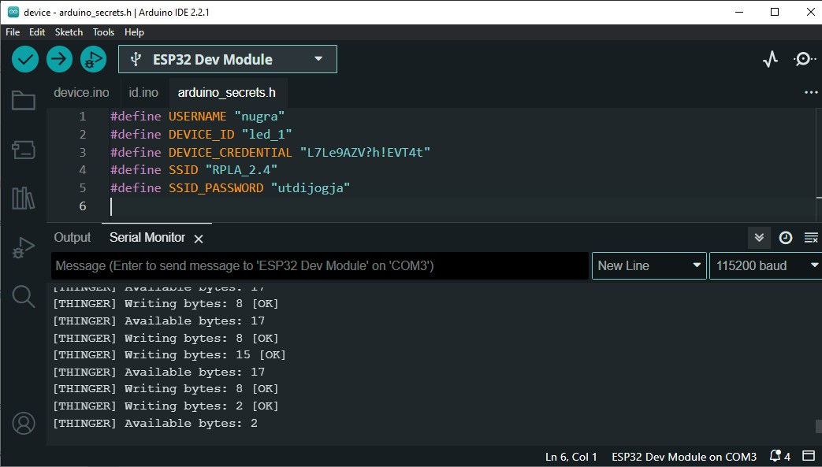- Code Arduino / id

|  |
| --- |
| #define USERNAME "nugra" |
| #define DEVICE_ID "led_1" |
| #define DEVICE_CREDENTIAL "L7Le9AZV?h!EVT4t" |
| #define SSID "RPLA_2.4" |
| #define SSID_PASSWORD "utdijogja" |

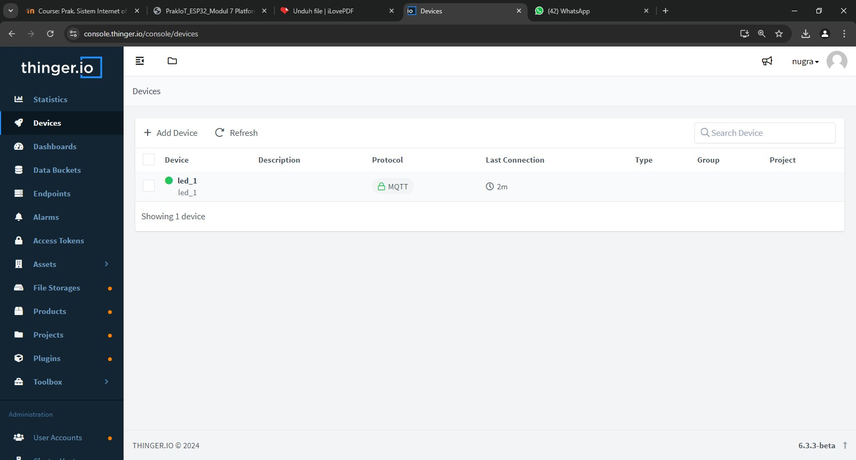

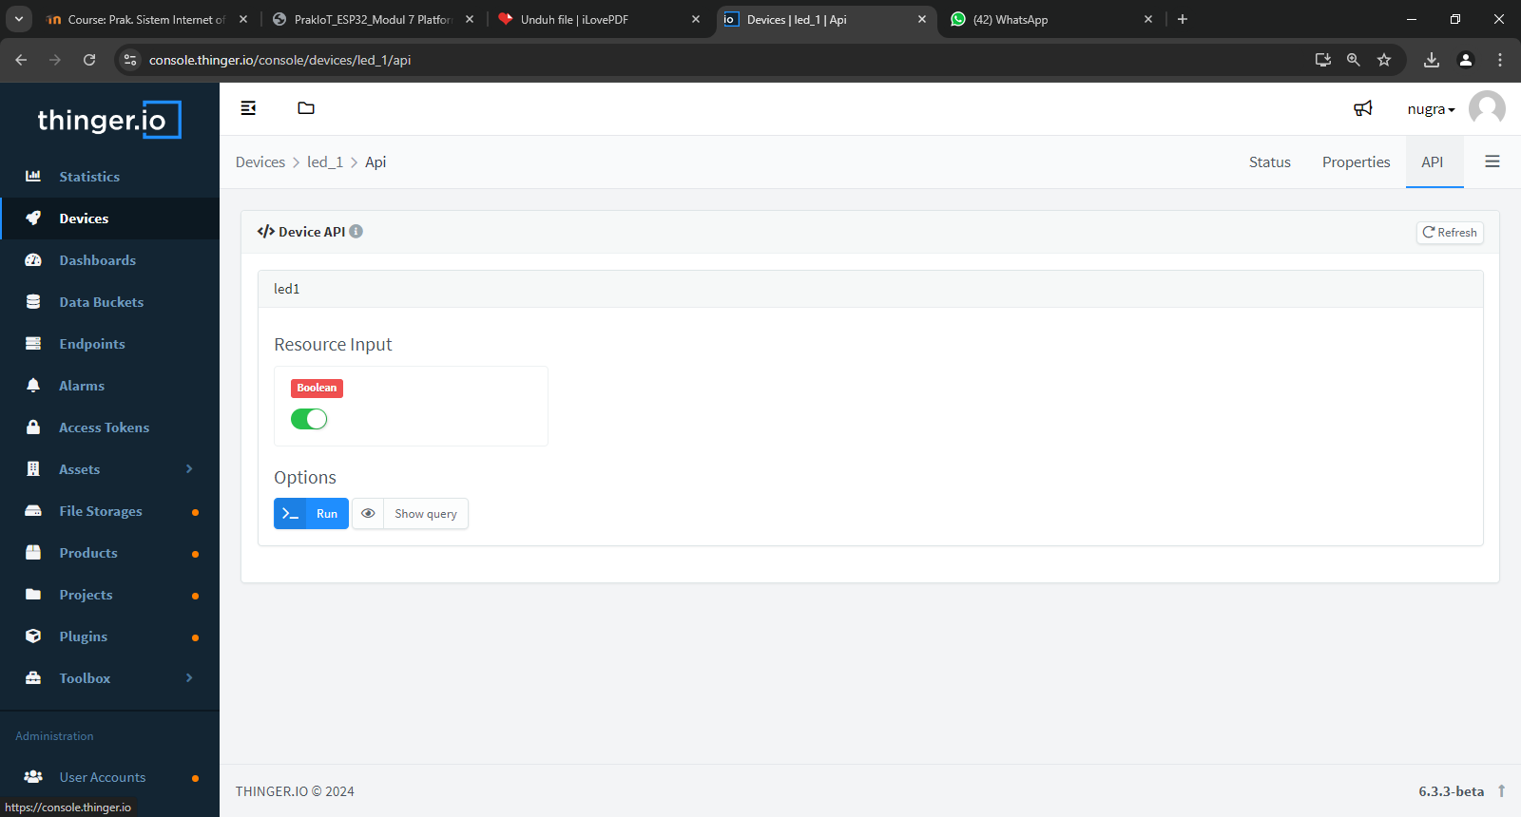

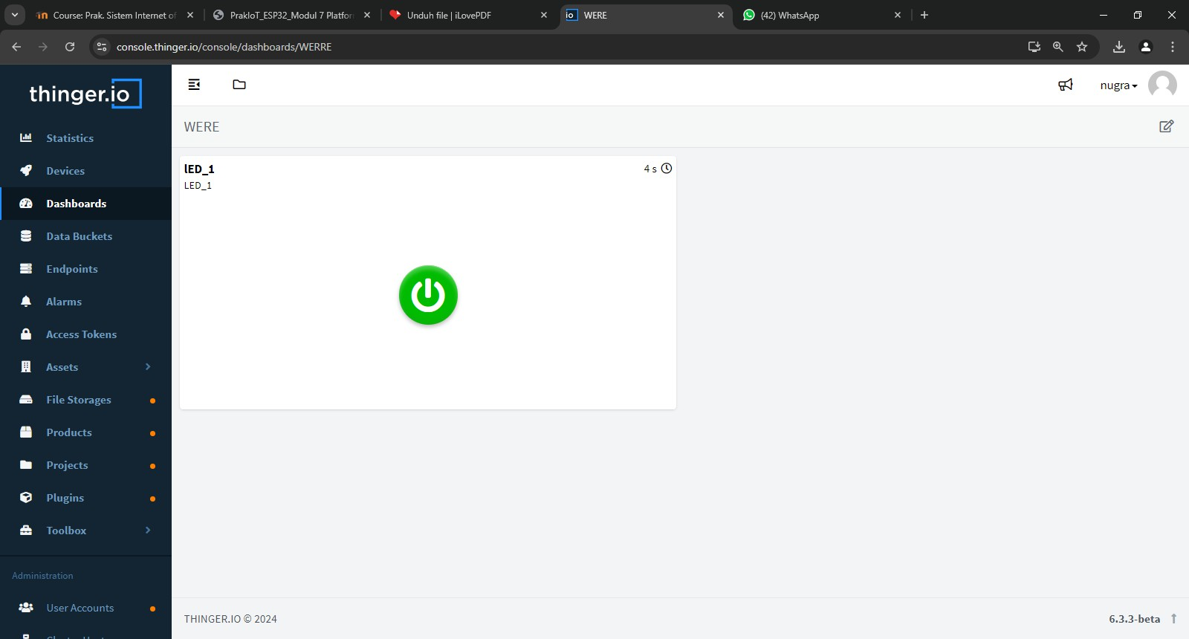

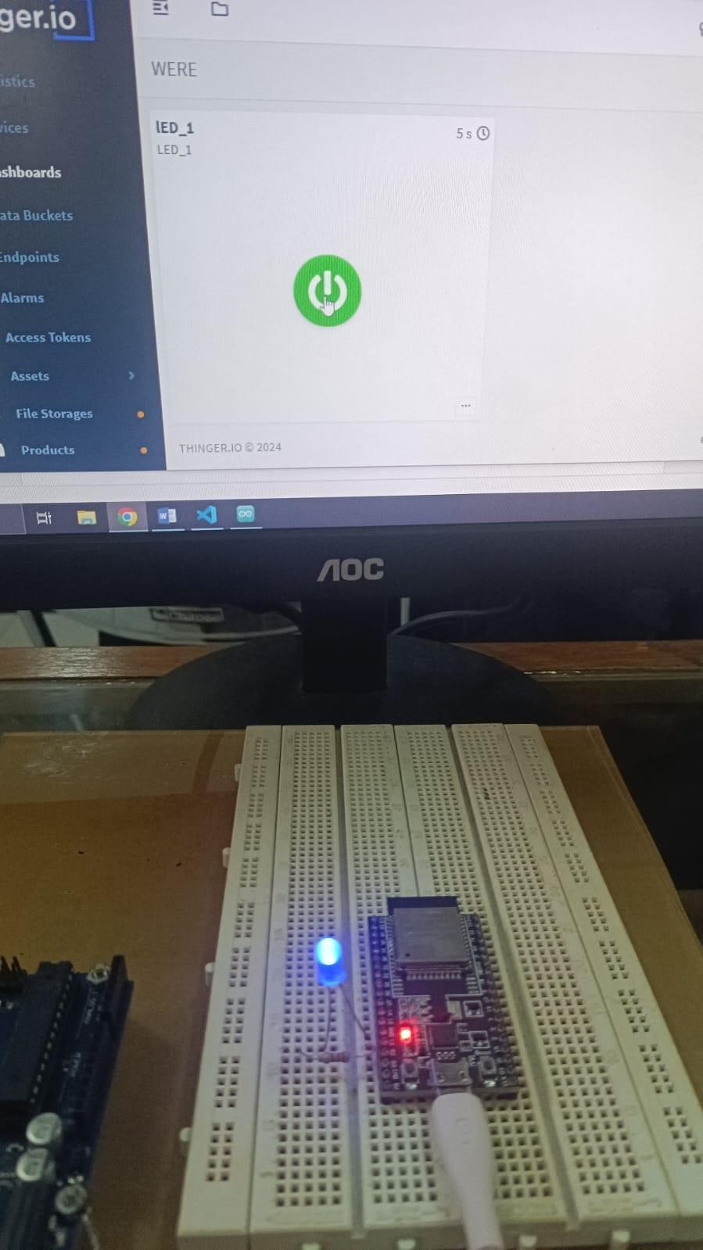

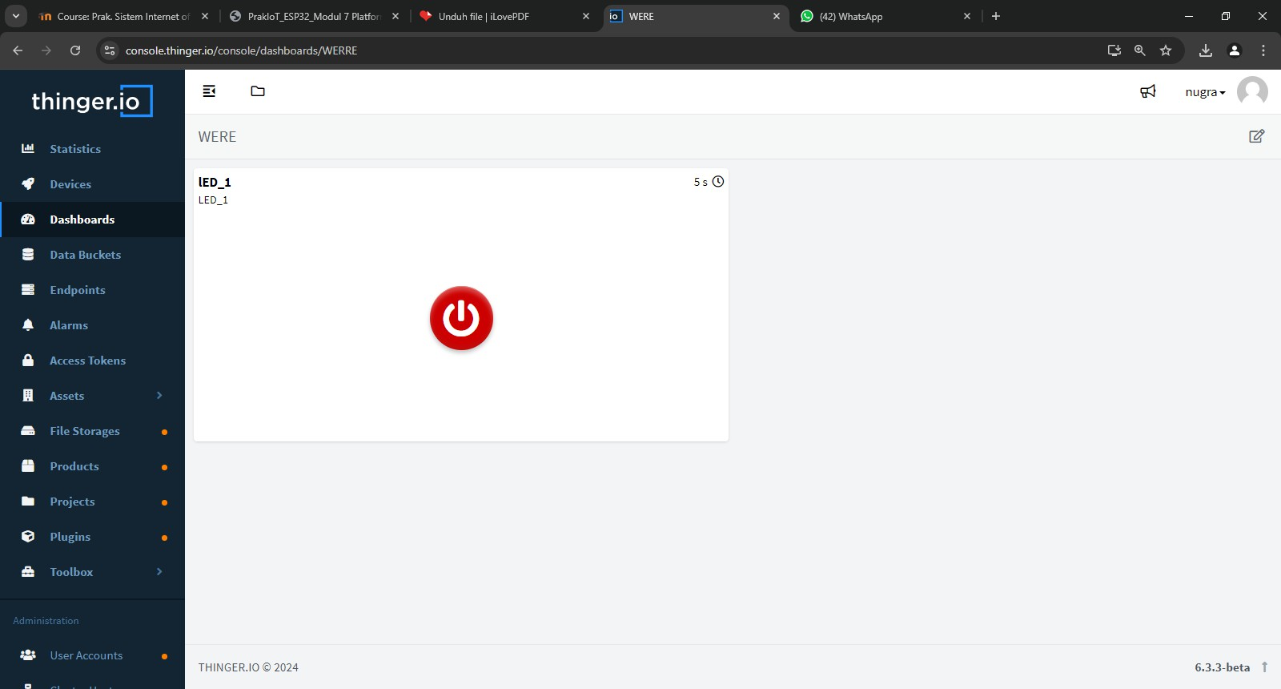

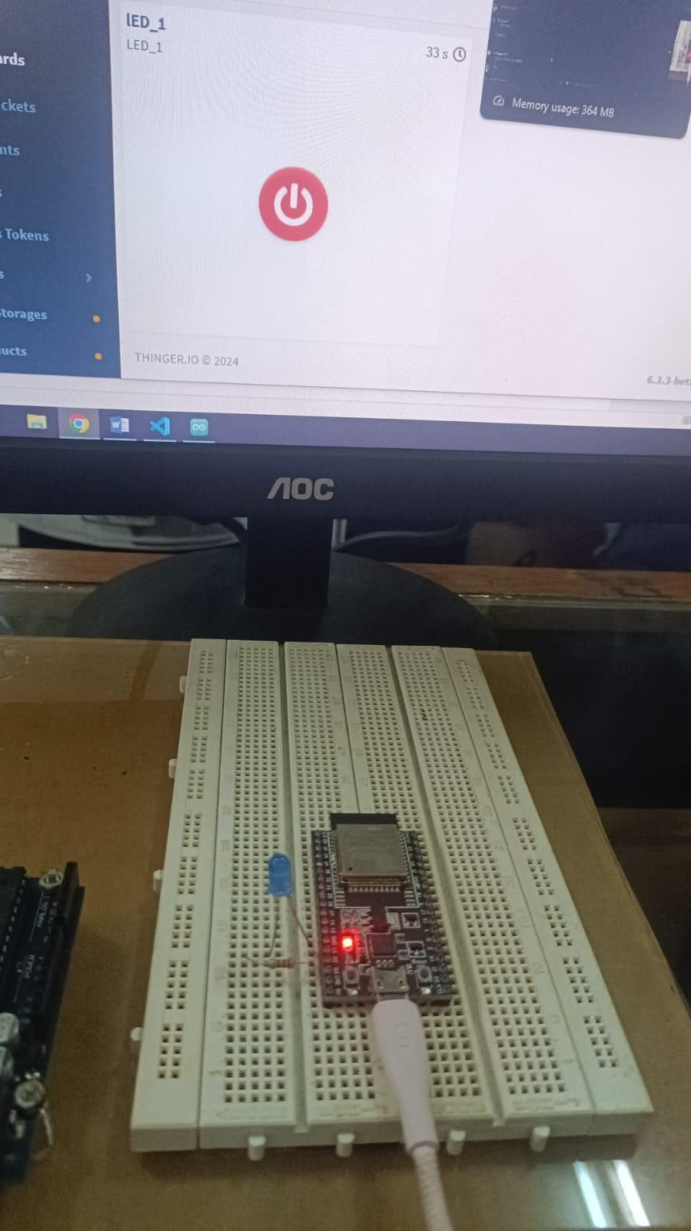

**Tugas**

